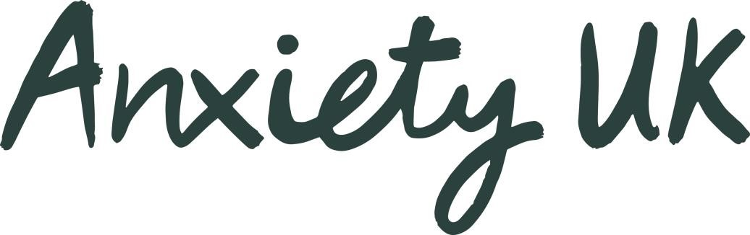

|  |  |
| --- | --- |
| **Checklist and approach when making first contact with the client** | **Checked?** |
|  |
| **Explain the relationship between therapist and Anxiety UK**    I provide therapy to clients that have approached Anxiety UK requesting support with an Anxiety related matter.  The reduced rate or free service that I offer to Anxiety UK is in addition to my other therapeutic work. I do this because I want to give something back and ensure that individuals seeking support with Anxiety can do both quickly and affordably.  I am a qualified (or trainee) therapists and meet the requirements set out by Anxiety UK to offer therapeutic services to clients that seek support through them. |  |
| **Explain that you will be sending the client a contract to sign.**  Inform the client that you will be sending them a contract to sign, until this is signed and returned you will be unable to offer any therapeutic support.  The purpose of the contact is to set out the arrangement between you as a therapists and them as a client.  Reassure the client that any matters discussed remain confidential and the only information fed back to Anxiety UK is statistical data such as number of sessions and opening closing scores, these are aggregated and used only for reporting at an anonymised level. |  |
| **Explain that each session will involve completing GAD7 & PHQ9 scores.**  Reassure the client that these are used to help shape the therapy that you will be providing. The scores also give an indication of how well the therapy is working. |  |
| **Explain the purpose of the first session and the process for the therapeutic interaction.**  Ensure the client understand that session 1 will form the basis of an assessment whereby you will agree the approach for the therapy and possible number of sessions, let the client know that NICE guidelines are used to help determine how many sessions may be appropriate. |  |
| **Ask if the client has any questions.**  Agree the best way of communicating with the client, remembering that if social media is used this should only be for agreeing/changing appointments. |  |

Document Ref AUKAT004 Reviewed May 24